
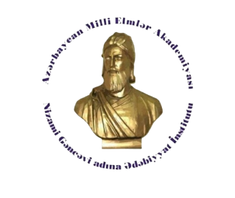
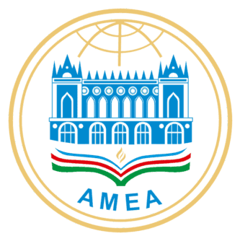
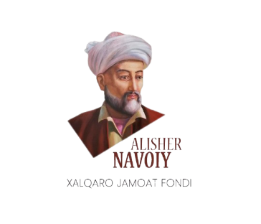
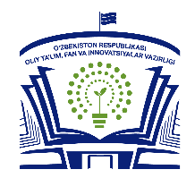

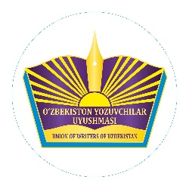
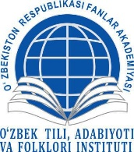

MINISTRY OF HIGHER EDUCATION, SCIENCE AND INNOVATION OF THE REPUBLIC OF UZBEKISTAN,
KOKAND UNIVERSITY,
THE WRITERS’ UNION OF UZBEKISTAN,
INSTITUTE OF UZBEK LANGUAGE, LITERATURE AND FOLKLORE OF THE ACADEMY OF SCIENCES OF UZBEKISTAN,
STATE LITERATURE MUSEUM NAMED AFTER ALISHER NAVOIY,
INTERNATIONAL PUBLIC FOUNDATION NAMED AFTER ALISHER NAVOIY,
NATIONAL ACADEMY OF SCIENCES OF AZERBAIJAN,
NIZAMI GANJAVI INSTITUTE OF LITERATURE, INSTITUTE OF PHILOSOPHY AND SOCIOLOGY,
KARABÜK UNIVERSITY OF THE REPUBLIC OF TÜRKİYE

INFORMATION LETTER

In order to ensure the implementation of the 2026 plan of international and national scientific events approved by the Ministry of Higher Education, Science and Innovation of the Republic of Uzbekistan, as well as to celebrate at a high academic level the 885th anniversary of the birth of Nizami Ganjavi and the 585th anniversary of the birth of Alisher Navoi — two outstanding representatives of Eastern classical literature — and to deeply study the spiritual and philosophical heritage of our ancestors through modern scientific approaches, we hereby inform you that on February 12, 2026, an International Scientific and Practical Conference entitled:
“The Literary Heritage of Nizami and Navoi: The Harmony of Artistic Imagery and Human Philosophy” will be held at Kokand University.
The main purpose of the conference is to provide a scientific and theoretical analysis of the harmony of artistic thinking, philosophical reflection, the concept of the perfect human being, love, and spirituality in the works of Nizami Ganjavi and Alisher Navoi, as well as to highlight their place and influence in the global literary process.
The conference will be organized in the following sections:
Section 1. The system of artistic imagery in the works of Nizami and Navoi
Section 2. Human philosophy and the idea of perfection
Section 3. Comparative studies of the works of Nizami and Navoi
Section 4. Socio-philosophical ideas in the works of Nizami and Navoi
Section 5. The heritage of Nizami and Navoi in the context of world literature
Conference languages: All Turkic languages
Conference objective: To analyze the ideas of the perfect human being promoted in the works of Nizami Ganjavi and Alisher Navoi from literary, philosophical, and cultural perspectives; to reveal aspects of their mutual influence and intellectual succession; and to scientifically substantiate the significance of this heritage in the spiritual life of modern society and in educational processes.
Deadline for paper submission: Articles related to the conference theme are accepted until February 4, 2026.
Requirements for formatting scientific articles and abstracts:
- The article length must be 7–10 pages.
- Manuscripts should be prepared in DOC format, with 1.15 line spacing, using Times New Roman, 14 pt font.
- The article title, abstract (100–150 words), and keywords (7–9 words) must be provided in the language of submission.
- The author’s full name should be indicated after the title, along with academic degree, academic title, institutional affiliation, and email address.
All submissions will be checked using anti-plagiarism software.
Abstract: A brief abstract must be provided in both the language of the article and in English. The abstract should reflect the research problem, its relevance, results, proposals, and conclusions, clearly presenting the author’s scientific and practical contribution.
Keywords: Keywords should concisely reflect the content and purpose of the article. To improve discoverability in search engines such as scholar.google.com and google.com, it is recommended that each keyword be repeated approximately 5–10 times within the main text.
References: All sources used in the research should be listed in numerical order, e.g. [1, 24], [2, 18], [3, 56].
Manuscripts that do not meet these requirements will not be accepted. The author bears full responsibility for the accuracy of examples, quotations, and data used in the text. The Organizing Committee does not undertake any obligation to return or comment on manuscripts that do not pass the selection process.
Submission of articles and abstracts: Papers should be submitted electronically via: imomaliyevamusharrafxon@gmail.com Telegram: @Imomaliyeva_Musharrafxon
Conference materials will be indexed in Google Scholar, and participants will be awarded certificates.
Articles that meet the established requirements will be included in the conference proceedings and published on the official website of Kokand University (www.kokanduni.uz) and on social media platforms.

